BIOLOGICAL TECHNIQUES
Lesson 1: Microscopy
Microscopy is the technical field of using microscopes to view samples & objects that cannot be seen with the unaided eye (objects that are not within the resolution range of the normal eye).
MICROSCOPE: Is an instrument for viewing objects that are too small to be seen by the naked or unaided eye.

What is microscopy and what is it used for?
Light microscopy is a general term used for any type of microscopy where light is being transmitted from a source which is on the opposite side of the sample, to the objective lens. Generally, the light is passed through a condenser to focus it on the sample to have maximum brightness. After the light has passed through the sample, it goes through the objective lens to magnify the image of the sample & then to the oculars, where the enlarged image is viewed.

Types of Microscopes
A good microscope should have three properties:
- Good resolution: Resolution power refers to the ability to produce separate images of closely placed objects so that they can be distinguished as two separate entities. The resolution power of:
  - The unaided human eye is about 0.2 mm (200 μm)
  - The light microscope is about 0.2 μm
  - An electron microscope is about 0.5 nm
The resolution depends on refractive index. Oil has a higher refractive index than air.
- Good contrast: This can be further improved by staining the specimen.
- Good magnification: This is achieved by the use of concave lenses.
History of microscopy
- MICROSCOPE: Is an instrument for viewing objects that are too small to be seen by the naked or unaided eye.
- A microscope (Greek: mikron = small and skopein = to look).
- MICROSCOPY: The science of investigating small objects using a microscope
- 1590 - Hans Janssen and his son Zacharias Janssen, developed first microscope.
• 1609 - Galileo Galilei
- 1625 – Giovanni Faber coined the name microscope for the compound microscope Galileo submitted to the Accademia dei Lincei
- 1590 - Hans Janssen and his son Zacharias Janssen, developed first microscope.
Parts of microscope
An eyepiece is that part of an optical system, which is directed to the viewer. It is a construction of at least one or more lenses. The function of the eyepiece in a microscope is to convert the real- enlarged-intermediate-image from the objective into an enlarged-virtual-image. It contains the ocular lens, which the user looks through to see the magnified specimen. The ocular lens has a magnification that can range from 5x to 30x, but 10x or 15x is the most common setting.
Lens tube The lens tube is connected with the eyepiece and it´s main task is to hold it.
The diopter adjustment
- It is a control knob on your binocular. It is designed to let you compensate for differences between your own two eyes. Once you set the diopter, then the two barrels should stay in proper relation.
The objective lenses
- It combines with the eyepiece lens to increase magnification levels. Microscopes generally feature three or four objective lenses, with magnification levels ranging 4x to 100x.
- Objective revolvers are used in microscopes with multiple objective lenses, that have different magnification factors.
- An objective (lens) is that part of an optical system, which is directed to the object. It´s task is to collect the light rays, that are reflected from the observed item. The objective generates a real-optical image.

The Microscope Illuminator
- Microscopes require a light source for viewing. This can come in the form of a built-in, low-voltage illuminator light, or a mirror that reflects an external light source like sunlight.

Stage and Stage Clips
- The stage is a platform for the slides, which hold the specimen. The stage typically has a stage clip on either side to hold the slide firmly in place. Some microscopes have a mechanical stage, with adjustment knobs that allow for more precise positioning of slides.
Clip
- The clip serves as a holder for the object plate and makes sure, that it doesn´t get out of its place unintentionally

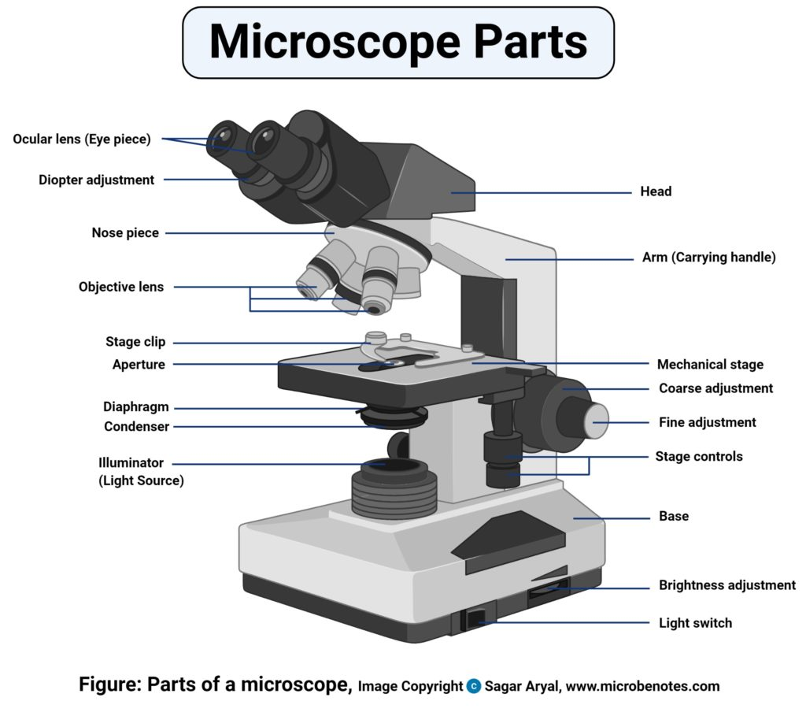

Lesson 2: MAGNIFICATION, RESOLUTION and PRINCIPLE of a microsope

Types
- Depending on the number of lenses, there are two i. e
- Simple light microscopes: use a single lens to magnify an object and cannot reach high magnification.
- Compound light microscope (it has a higher magnification compared to the simple microscope because it uses at least two sets of lenses, an objective lens, and an eyepiece).
- The lenses are aligned in that, they can be able to bend light for efficient magnification of the image.
- The simplest microscope of all is a magnifying glass made from a single convex lens, which typically magnifies by about 5–10 times.
- Microscopes used in homes, schools, and professional laboratories are actually compound microscopes and use at least two lenses to produce a magnified image.
- Most compound microscopes can magnify by 10, 20, 40, or 100 times
Magnification
Magnification on a microscope refers to the amount or degree of visual enlargement of an observed object. Magnification is measured by multiples, such as 2x, 4x and 10x, indicating that the object is enlarged to twice as big, four times as big or 10 times as big, respectively.

Magnification Limits
For a standard light-based microscope, the maximum magnification extends up to 1,500x; beyond this, objects under view become excessively fuzzy because the wavelengths of light limit the clarity of images. Electrons, on the other hand, have much shorter wavelengths. According to Auburn University, electron microscopes produce useful images with magnifications up to about 200,000x.

Magnification and Distance on a Microscope
The magnification on a microscope must be adjusted carefully in proportion to distance. For optical microscopes, the higher the magnification, the closer the lens must be positioned to the object being observed. If the lens gets too close, it may crash into the specimen, destroying the slide or specimen and possibly damaging the lens, so exercise great care when using magnifications over 100x. Most microscopes allow for adjustment of the lens-object distance, as well as providing preset default positions that place the higher magnification lenses closer to the slide.

- Degree of enlargement.
- No of times the length, breadth or diameter, of an object is multiplied.
- depends upon 3 factors
- Optical tube length
- Focal length of objective
- Magnifying power of eye piece
- Total magnification=magnification of the eyepiece x magnification of the objective.
=10x40 = 400
=10x100 = 1000

Principle of microscope
- Generally.. microscopes visualize an image by using a glass lens and magnification is determined by, the lens’s ability to bend light and focus it on the specimen, which forms an image.
- When a ray of light passes through one medium into another, the ray bends at the interface causing refraction.
- The bending of light is determined by the refractive index, which is a measure of how great a substance slows the speed of light. The direction and magnitude of the bending of the light are determined by the refractive indexes of the two mediums that form the interface.
- A medium with a lower refractive index such as glass to air, it normally speeds up the light penetration and making light bend away from the normal and when light is passed through a medium with a greater refractive index such as air to glass, it normally slows down and bends towards the normal, perpendicularly to the surface.
- If an object is put between these two mediums i.e between water and air, in this case, a prism, the prism will bend the light at an angle. This is how the microscopic lenses work, they bend the light at an angle.
- Refraction is the change in direction of a wave passing from one medium to another.
- Refraction of light waves is the most commonly observed phenomenon, but other waves such as sound waves and water waves also experience refraction.
- Refractive index, also called index of refraction, measure of the bending of a ray of light when passing from one medium into another.

Lesson 3: MAGNIFICATION, RESOLUTION and PRINCIPLE of a microsope.2
Microscope resolution is the shortest distance between two separate points in a microscope’s field of view that can still be distinguished as distinct entities.
If the two points are closer together than your resolution then they will appear ill-defined and their positions will be inexact. A microscope may offer high magnification, but if the lenses are of poor quality the resulting poor resolution will degrade the image quality. In microscopy, the term ‘resolution’ is used to describe the ability of a microscope to distinguish details of given specimen. This is the resolving power of microscope .In other words, this is the shortest distance (d) at which two distinct points of a specimen can still be distinguished - either by the observer or the microscope camera - as separate entities. Resolution is a somewhat subjective value in optical microscopy because at high magnification, an image may appear unsharp but still be resolved to the maximum ability of the objective. Numerical aperture determines the resolving power of an objective, but the total resolution of the entire microscope optical train is also dependent upon the numerical aperture of the substage condenser. The higher the numerical aperture of the total system, the better the resolution.
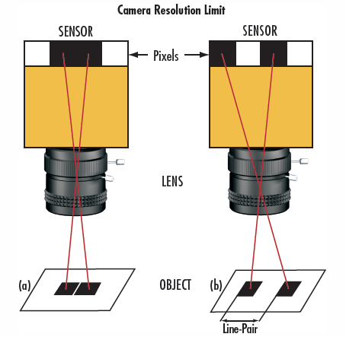
- d= λ/2 NA
- The resolution of a microscope is a function of two factors as given below:
- numerical aperture (NA) of the optical components
wavelength of light (λ)which is used to examine a specimen
- LIMIT OF RESOLUTION (LR): The minimum distance between any two closest points on the microscopic object, which can be resolved into two separate and distinct points on the enlarged image.
- d= λ/2 NA
The limit of resolution of a microscope objective refers to its ability to distinguish between two closely spaced Airy disks in the diffraction pattern. Three-dimensional representations of the diffraction pattern near the intermediate image plane are known as the point spread function; The specimen image is represented by a series of closely spaced point light sources that form Airy patterns and is illustrated in both two and three dimensions.

Lesson 4: Nuclear aperture of microscope

The numerical aperture of a microscope objective is a measure of its ability to gather light and resolve fine specimen detail at a fixed object distance. Image-forming light waves pass through the specimen and enter the objective in an inverted cone as illustrated in Figure 1. A longitudinal slice of this cone of light shows the angular aperture, a value that is determined by the focal length of the objective.
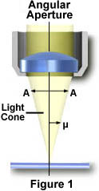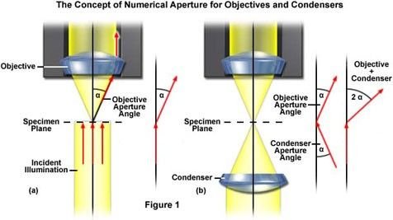

- Numerical aperture is a number that expresses the ability of a lens to resolve fine details in an object being observed.
- In MICROBIOLOGY, the numerical aperture of a microscope objective is a measure of its ability to gather light and resolve fine details of the specimen at a fixed object distance. light waves that are forming the Image pass through the specimen and enter the objective in an inverted cone as shown in fig 1
- Numerical aperture is concerned with the diameter of the objective lens in relation to its focal length.
- Thus, it is related to the size of the lower aperture of the objective, through which light enters into it.

- Higher values of numerical aperture permit increasingly oblique rays to enter the objective front lens, which produces a more highly resolved image and allows smaller structures to be visualized with higher clarity.
- Numerical Aperture (NA) = n x sin(α).... equation 1
- where
- n = Refractive index of the medium between the object and the objective (or the objective and the cover slip )
- α = Half aperture angle (equals one-half of the objective's opening angle)
- (n = 1 for air; n = 1.51 for oil or glass).
- By examining Equation (1), it is apparent that the refractive index is the limiting factor in achieving numerical apertures greater than 1.0.
- Therefore, in order to obtain higher working numerical apertures, the refractive index of the medium between the front lens of the objective and the specimen cover slip must be increased.

Lesson 5: Bright-field microscopy
Brightfield Microscope is also known as the Compound Light Microscope. It is an optical microscope that uses light rays to produce a dark image against a bright background. It is the standard microscope that is used in Biology, Cellular Biology, and Microbiological Laboratory studies.
This microscope is used to view fixed and live specimens, that have been stained with basic stains which gives a contrast between the image and the image background. It is specially designed with magnifying glasses known as lenses that modify the specimen to produce an image seen through the eyepiece.

Principle of Brightfield Microscope
For a specimen to be the focus and produce an image under the Brightfield Microscope, the specimen must pass through a uniform beam of the illuminating light. Through differential absorption and differential refraction, the microscope will produce a contrasting image.
The specimens used are prepared initially by staining to introduce color for easy contracting characterization. The colored specimens will have a refractive index that will differentiate it from the surrounding, presenting a combination of absorption and refractive contrast.
The functioning of the microscope is based on its ability to produce a high-resolution image from an adequately provided light source, focused on the image, psroducing a high-quality image.
The specimen which is placed on a microscopic slide is viewed under oil immersion or/and covered with a coverslip.

Parts of Brightfield Microscope
The brightfield microscope is made up of various parts, including
- Eyepiece (Ocular lens) – it has two eyepiece lenses at the top of the microscope which focuses the image from the objective lenses. this is where you see the formed image from, with your eyes.
- The objective lenses which are made up of six or more glass lenses, which make a clear image clear from the specimen or the object that is being focused.
- Two focusing knobs i.e the fine adjustment knob and the coarse adjustment knob, found on the microscopes’ arm, which can move the stage or the nosepiece to focus on the image. Their function is to ensure the production of a sharp image with clarity.
- The stage is found just below the objectives and this is where the specimen is placed, allowing movement of the specimen around for better viewing with the flexible knobs and it is where the light is focused on.
- The condenser: It is mounted below the stage which focuses a beam of light onto the specimen. It can be fixed or movable, to adjust the quality of light, but this entirely depends on the microscope.
- The arm: This is a sturdy metallic backbone of the microscope, used to carry and move the microscope from one place to another. They also hold the microscope base which is the stand of the microscope. The arm and the base hold all the microscopic parts.
- It has a light illuminator or a mirror found at the base or on the microscope’s nosepiece.
- The nosepiece has about two to five objective lenses with different magnifying power. It can move round to any position depending on the objective lens to focus on the image.
- An aperture diaphragm (contrast): It controls the diameter of the beam of light that passes through the condenser. When the condenser is almost closed, the light comes through to the center of the condenser creating high contrast and when the condenser is widely open, the image is very bright with very low contrast.

Magnification by Brightfield Microscope
- The objective lenses are the main lenses used for focusing the image, on the condenser. This produces an enlarged clear image that is then magnified again by the eyepiece to form the primary image that is seen by the eyes.
- During imaging, the objective lenses remain parfocal in that, even when the objective lens has changed the image still remains focused. The image seen at the eyepiece is the enlarged clear image of the specimen, known as the virtual image.
- The magnification of the image is determined by the magnification of the objective against the magnification of the eyepiece lens. The objectives have a magnification power of 40x-1000x depending on the type of brightfield microscope while the eyepiece lens has a standard magnification power of 10x.
- Therefore to calculate:
Total Magnification power = Magnification of the objective lens x Magnification of the eyepiece
- For example: if the magnification of the objective is 45x and that of the eyepiece is 10x, the total magnification of the specimen will be 450x.
- The magnification is standard, i.e not too high nor too low, and therefore depending on the magnification power of the lenses, it will range between 40X and 100oX.
- The objective lens enlarges the image which can be viewed, a characteristic known as resolution. Resolution according to Prescott, is the ability of a lens to separate or distinguish between small objects closely linked together.
- Whereas the eyepiece magnifies the image at the end of the viewing, its magnification range is lower than that of the objective lens at 8X-12X (10X standard) and that of the objective lens at 40X-100X, magnification, and resolution of the microscope is highly dependant on the objective lens.

Applications of Brightfield microscope
Brightfield Microscope is used in several fields, from basic biology to understanding cell structures in cell Biology, Microbiology, Bacteriology to visualizing parasitic organisms in Parasitology.
Most of the specimens to viewed are stained using special staining to enable visualization. Some of the staining techniques used include Negative staining and Gram staining.
Some of its applications include:
- Used to visualize and study the animal cells
- Used to visualize and study plant cells.
- Used to visualize and study the morphologies of bacterial cells
- Used to identify parasitic protozoans such as Paramecium.

Advantages of Brightfield Microscope
- It is simple to use with few adjustments involved while viewing the image.
- It can be used to view both stained and unstained.
- The optics of the microscope do not alter the color of the specimen.
- The microscope can be adjusted and modified for better viewing such as installing a camera, to form a digital microscope or in the way image illumination is done such as by use of fluorochromes on the specimen and viewing under a dark environment, forming a darkfield microscope.

Disadvantages
- The aperture diaphragm may cause great contrast which may distort the outcome of the image, therefore iris diaphragm is preferred.
- It can not be used to view live specimens such as bacterial cells. Only fixed specimens can be viewed under the brightfield microscope.
- Maximum magnification of the brightfield microscope is 100x but modification can readjust the magnification to 1000x which is the optimum magnification of bacterial cells.
- It has low contrast hence most specimens must be stained for them to be visualized.
- Use of oil immersion may distort the image
- The use of coverslip may damage the specimen
- Staining may introduce extraneously unwanted details into the specimen or contaminate the specimen.
- It is tedious to stain the specimen before visualizing it under the brightfield microscope.
- The microscope needs a strong light source for magnification and sometimes the light source may produce a lot of heat which may damage or kill the specimen.

Parts of Brightfield Microscope

Figure: Parts of Brightfield Microscope (Compound Light Microscope). Image created using biorender.com
The brightfield microscope is made up of various parts, including
- Eyepiece (Ocular lens) – it has two eyepiece lenses at the top of the microscope which focuses the image from the objective lenses. this is where you see the formed image from, with your eyes.
- The objective lenses which are made up of six or more glass lenses, which make a clear image clear from the specimen or the object that is being focused.
- Two focusing knobs i.e the fine adjustment knob and the coarse adjustment knob, found on the microscopes’ arm, which can move the stage or the nosepiece to focus on the image. Their function is to ensure the production of a sharp image with clarity.
- The stage is found just below the objectives and this is where the specimen is placed, allowing movement of the specimen around for better viewing with the flexible knobs and it is where the light is focused on.
- The condenser: It is mounted below the stage which focuses a beam of light onto the specimen. It can be fixed or movable, to adjust the quality of light, but this entirely depends on the microscope.
- The arm: This is a sturdy metallic backbone of the microscope, used to carry and move the microscope from one place to another. They also hold the microscope base which is the stand of the microscope. The arm and the base hold all the microscopic parts.
- It has a light illuminator or a mirror found at the base or on the microscope’s nosepiece.
- The nosepiece has about two to five objective lenses with different magnifying power. It can move round to any position depending on the objective lens to focus on the image.
- An aperture diaphragm (contrast): It controls the diameter of the beam of light that passes through the condenser. When the condenser is almost closed, the light comes through to the center of the condenser creating high contrast and when the condenser is widely open, the image is very bright with very low contrast.

Magnification by Brightfield Microscope
- The objective lenses are the main lenses used for focusing the image, on the condenser. This produces an enlarged clear image that is then magnified again by the eyepiece to form the primary image that is seen by the eyes.
- During imaging, the objective lenses remain parfocal in that, even when the objective lens has changed the image still remains focused. The image seen at the eyepiece is the enlarged clear image of the specimen, known as the virtual image.
- The magnification of the image is determined by the magnification of the objective against the magnification of the eyepiece lens. The objectives have a magnification power of 40x-1000x depending on the type of brightfield microscope while the eyepiece lens has a standard magnification power of 10x.
- Therefore to calculate:
Total Magnification power = Magnification of the objective lens x Magnification of the eyepiece
- For example: if the magnification of the objective is 45x and that of the eyepiece is 10x, the total magnification of the specimen will be 450x.
- The magnification is standard, i.e not too high nor too low, and therefore depending on the magnification power of the lenses, it will range between 40X and 100oX.
- The objective lens enlarges the image which can be viewed, a characteristic known as resolution. Resolution according to Prescott, is the ability of a lens to separate or distinguish between small objects closely linked together.
- Whereas the eyepiece magnifies the image at the end of the viewing, its magnification range is lower than that of the objective lens at 8X-12X (10X standard) and that of the objective lens at 40X-100X, magnification, and resolution of the microscope is highly dependant on the objective lens.

Applications of Brightfield microscope
Brightfield Microscope is used in several fields, from basic biology to understanding cell structures in cell Biology, Microbiology, Bacteriology to visualizing parasitic organisms in Parasitology.
Most of the specimens to viewed are stained using special staining to enable visualization. Some of the staining techniques used include Negative staining and Gram staining.
Some of its applications include:
- Used to visualize and study the animal cells
- Used to visualize and study plant cells.
- Used to visualize and study the morphologies of bacterial cells
- Used to identify parasitic protozoans such as Paramecium.

Advantages of Brightfield Microscope
- It is simple to use with few adjustments involved while viewing the image.
- It can be used to view both stained and unstained.
- The optics of the microscope do not alter the color of the specimen.
- The microscope can be adjusted and modified for better viewing such as installing a camera, to form a digital microscope or in the way image illumination is done such as by use of fluorochromes on the specimen and viewing under a dark environment, forming a darkfield microscope.

Disadvantages
- The aperture diaphragm may cause great contrast which may distort the outcome of the image, therefore iris diaphragm is preferred.
- It can not be used to view live specimens such as bacterial cells. Only fixed specimens can be viewed under the brightfield microscope.
- Maximum magnification of the brightfield microscope is 100x but modification can readjust the magnification to 1000x which is the optimum magnification of bacterial cells.
- It has low contrast hence most specimens must be stained for them to be visualized.
- Use of oil immersion may distort the image
- The use of coverslip may damage the specimen
- Staining may introduce extraneously unwanted details into the specimen or contaminate the specimen.
- It is tedious to stain the specimen before visualizing it under the brightfield microscope.
- The microscope needs a strong light source for magnification and sometimes the light source may produce a lot of heat which may damage or kill the specimen.
Bottom of Form
Bottom of Form

Bottom of Form

Lesson no. 6; Dark-field microscopy

Principle: In a dark field microscope, the object appears bright against a dark background. This is made possible by the use of a special darkfield condenser.
Applications: It is used to identify the living, unstained cells and thin bacteria like spirochetes which cannot be visualized by light microscopy.
- A dark field microscope is arranged so that the light source is blocked off, causing light to scatter as it hits the specimen.
- This is ideal for making objects with refractive values similar to the background appear bright against a dark background.
- When light hits an object, rays are scattered in all azimuths or directions. The design of the dark field microscope is such that it removes the dispersed light, or zeroth order, so that only the scattered beams hit the sample.
- The introduction of a condenser and/or stop below the stage ensures that these light rays will hit the specimen at different angles, rather than as a direct light source above/below the object.
- The result is a “cone of light” where rays are diffracted, reflected and/or refracted off the object, ultimately, allowing the individual to view a specimen in dark field.
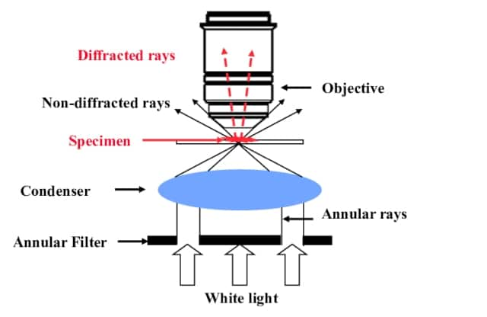
Uses
The dark ground microscopy has the following uses:
- It is useful for the demonstration of very thin bacteria not visible under ordinary illumination since the reflection of the light makes them appear larger.
- This is a frequently used method for rapid demonstration of Treponema pallidum in clinical specimens.
- It is also useful for the demonstration of the motility of flagellated bacteria and protozoa.
- Darkfield is used to study marine organisms such as algae, plankton, diatoms, insects, fibers, hairs, yeast and protozoa as well as some minerals and crystals, thin polymers and some ceramics.
- Darkfield is used to study mounted cells and tissues.
- It is more useful in examining external details, such as outlines, edges, grain boundaries and surface defects than internal structure.
Advantages
- Dark-field microscopy is a very simple yet effective technique.
- It is well suited for uses involving live and unstained biological samples, such as a smear from a tissue culture or individual, water-borne, single-celled organisms.
- Considering the simplicity of the setup, the quality of images obtained from this technique is impressive.
- Dark-field microscopy techniques are almost entirely free of artifacts, due to the nature of the process.
- A researcher can achieve a dark field by making modifications to his/her microscope.
Limitations
- The main limitation of dark-field microscopy is the low light levels seen in the final image.
- The sample must be very strongly illuminated, which can cause damage to the sample.

Lesson no.7
Phase contrast microscopy

Phase contrast microscopy, first described in 1934 by Dutch physicist Frits Zernike, is a contrast-enhancing optical technique that can be utilized to produce high-contrast images of transparent specimens, such as living cells (usually in culture), microorganisms, thin tissue slices, lithographic patterns, fibers, latex dispersions, glass fragments, and subcellular particles (including nuclei and other organelles).
One of the major advantages of phase contrast microscopy is that living cells can be examined in their natural state without previously being killed, fixed, and stained. As a result, the dynamics of ongoing biological processes can be observed and recorded in high contrast with sharp clarity of minute specimen detail.
Presented in Figure 1 is a cut-away diagram of a modern upright phase contrast microscope, including a schematic illustration of the phase contrast optical train. Partially coherent illumination produced by the tungsten-halogen lamp is directed through a collector lens and focused on a specialized annulus (labeled condenser annulus) positioned in the substage condenser front focal plane. Wavefronts passing through the annulus illuminate the specimen and either pass through undeviated or are diffracted and retarded in phase by structures and phase gradients present in the specimen. Undeviated and diffracted light collected by the objective is segregated at the rear focal plane by a phase plate and focused at the intermediate image plane to form the final phase contrast image observed in the eyepieces
Figure 1 - Phase Contrast Microscope Configuration
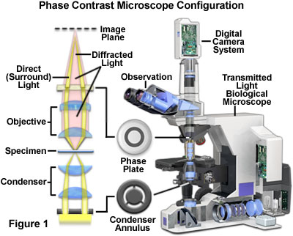

Principle:
When light passes through cells, small phase shifts occur, which are invisible to the human eye. In a phase-contrast microscope, these phase shifts are converted into changes in amplitude, which can be observed as differences in image contrast.
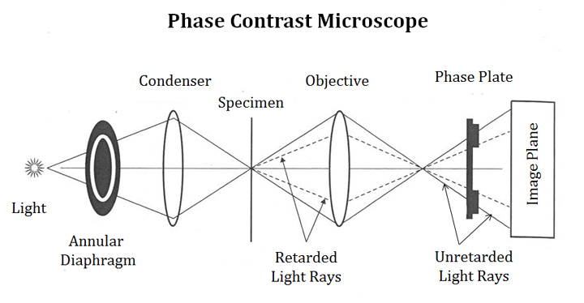

Applications of Phase contrast Microscopy
To produce high-contrast images of transparent specimens, such as
- living cells (usually in culture),
- microorganisms,
- thin tissue slices,
- lithographic patterns,
- fibers,
- latex dispersions,
- glass fragments, and
- subcellular particles (including nuclei and other organelles).

Limitations
- Phase-contrast condensers and objective lenses add considerable cost to a microscope, and so phase contrast is often not used in teaching labs except perhaps in classes in the health professions.
- To use phase-contrast the light path must be aligned.
- Generally, more light is needed for phase contrast than for corresponding bright-field viewing, since the technique is based on the diminishment of the brightness of most objects.

Lesson 8
Working of phase contrast microscopy

A phase-contrast microscope splits a beam of light into 2 types of light, direct and refracted (reflected) and brings them together to form an image of the specimen.
- Where the lights are “in-phase” the image is brighter, where the lights are “out of phase” the image is darker, and by amplifying these differences in the light, it enhances contrast.
- Phase-contrast microscopy allows for the detailed observation of living organisms, especially the internal structures.
- refractive index: the ratio of the speed of light in air or vacuum to that in another medium.
- In phase-contrast microscopy, parallel beams of light are passed through objects of different densities. The microscope contains special condensers that throw light “out of phase” causing it to pass through the object at different speeds. Internal details and organelles of live, unstained organisms (e.g. mitochondria, lysosomes, and the Golgi body) can be seen clearly with this microscope.
- A phase ring in condenser allows a cylinder of light to pass through it while still in phase. Unaltered light hits the phase ring in the lens and is excluded. Light that is slightly altered by passing through a different refractive index is allowed to pass through. Light passing through cellular structures, such as chromosomes or mitochondria is retarded because they have a higher refractive index than the surrounding medium. Elements of lower refractive index advance the wave. Much of the background light is removed and light that constructively or destructively interfered is let through with enhanced contrast.
- Phase-contrast microscopy allows the visualization of living cells in their natural state with high contrast and high resolution. This tool works best with a thin specimen and is not ideal for a thick specimen. Phase-contrast images have a characteristic grey background with light and dark features found across the sample. One disadvantage of phase-contrast microscopy is halo formation called halo-light ring.

Lesson 9
Electron Microscopy

- An electron microscope is a microscope that uses a beam of accelerated electrons as a source of illumination.
- It is a special type of microscope having a high resolution of images, able to magnify objects in nanometres, which are formed by controlled use of electrons in vacuum captured on a phosphorescent screen.
- Ernst Ruska (1906-1988), a German engineer and academic professor, built the first Electron Microscope in 1931, and the same principles behind his prototype still govern modern EMs.

Working Principle of Electron microscope
Electron microscopes use signals arising from the interaction of an electron beam with the sample to obtain information about structure, morphology, and composition.
- The electron gun generates electrons.
- Two sets of condenser lenses focus the electron beam on the specimen and then into a thin tight beam.
- To move electrons down the column, an accelerating voltage (mostly between 100 kV-1000 kV) is applied between tungsten filament and anode.
- The specimen to be examined is made extremely thin, at least 200 times thinner than those used in the optical microscope. Ultra-thin sections of 20-100 nm are cut which is already placed on the specimen holder.
- The electronic beam passes through the specimen and electrons are scattered depending upon the thickness or refractive index of different parts of the specimen.
- The denser regions in the specimen scatter more electrons and therefore appear darker in the image since fewer electrons strike that area of the screen. In contrast, transparent regions are brighter.
- The electron beam coming out of the specimen passes to the objective lens, which has high power and forms the intermediate magnified image.
- The ocular lenses then produce the final further magnified image.

Parts of Electron microscope

EM is in the form of a tall vacuum column which is vertically mounted. It has the following components:
- Electron gun
- The electron gun is a heated tungsten filament, which generates electrons.
- Electromagnetic lenses
- Condenser lens focuses the electron beam on the specimen. A second condenser lens forms the electrons into a thin tight beam.
- The electron beam coming out of the specimen passes down the second of magnetic coils called the objective lens, which has high power and forms the intermediate magnified image.
- The third set of magnetic lenses called projector (ocular) lenses produce the final further magnified image.
- Each of these lenses acts as an image magnifier all the while maintaining an incredible level of detail and resolution.
- Specimen Holder
- The specimen holder is an extremely thin film of carbon or collodion held by a metal grid.
- Image viewing and Recording System.
- The final image is projected on a fluorescent screen.
- Below the fluorescent screen is a camera for recording the image.

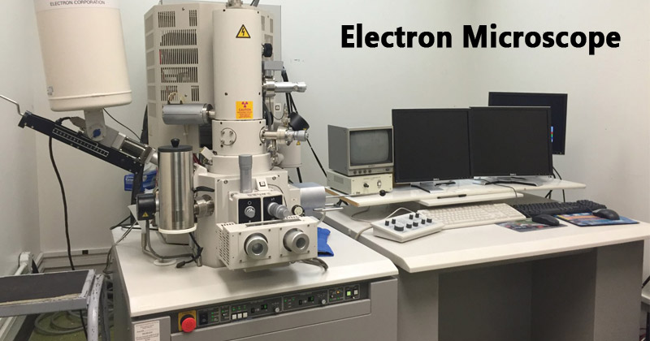

Advantages
- Very high magnification
- Incredibly high resolution
- Material rarely distorted by preparation
- It is possible to investigate a greater depth of field
- Diverse applications

Limitations
- The live specimen cannot be observed.
- As the penetration power of the electron beam is very low, the object should be ultra-thin. For this, the specimen is dried and cut into ultra-thin sections before observation.
- As the EM works in a vacuum, the specimen should be completely dry.
- Expensive to build and maintain
- Requiring researcher training
- Image artifacts resulting from specimen preparation.
- This type of microscope is a large, cumbersome extremely sensitive to vibration and external magnetic fields.

Lesson 10;
Components of TEM
- This is a powerful electron microscope that uses a beam of electrons to focus on a specimen producing a highly magnified and detailed image of the specimen.
- The magnification power is over 2 million times better than that of the light microscope, producing the image of the specimen which enables easy characterization of the image in its morphological features, compositions and crystallization information is also detailed.
- Early discovery of cathode rays like electrons by Louis de Broglie in the early 1920s, paved way into the development of an electron microscope where they used a beam of electrons creating a form of wave motion.
- Magnetic fields were used as lenses for the electrons. With these discoveries, the first electron microscope was later developed by Ernst Ruska and Max Knolls in 1931 and modified into a Transmission Electron Microscope (TEM) by Ernst Ruska along with the Sieman’s company, in 1933.

Principle of Transmission Electron Microscope (TEM)
The working principle of the Transmission Electron Microscope (TEM) is similar to the light microscope. The major difference is that light microscopes use light rays to focus and produce an image while the TEM uses a beam of electrons to focus on the specimen, to produce an image.
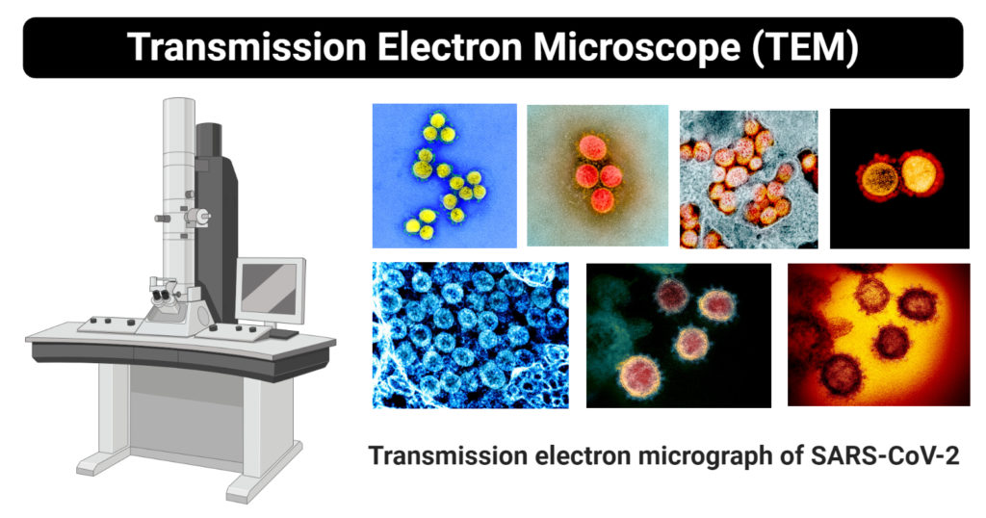

Parts of Transmission Electron Microscope (TEM)
Their working mechanism is enabled by the high-resolution power they produce which allows it to be used in a wide variety of fields. It has three working parts which include:
- Electron gun
- Image producing system
- Image recording system

Electron gun
- This is the part of the Transmission Electron Microscope responsible for producing electron beams.
- Electrons are produced by a cathode that is a tungsten filament that is V-shaped and it is normally heated. The tungsten filament is covered by a control grid known as a Wehnelt cylinder made up of a central hole which lies columnar to the tube. The cathode lies on top of or below the cylindrical column hole. The cathode and the control grid are negatively charged with an end of the anode which is disk-shaped that also has an axial hole.
- When electrons are transmitted from the cathode, they pass through the columnar aperture (hole) to the anode at high voltage with constant energy, which is efficient for focusing the specimen to produce an accurately defined image.
- It also has the condenser lens system which works to focus the electron beam on the specimen by controlling the energy intensity and the column hole of the electron gun. The TEM uses two condenser lenses to converge the beam of electrons to the specimen. The two condenser lens each function to produce an image i.e the first lens which has strong magnification, produces a smaller image of the specimen, to the second condenser lens, directing the image to the objectives.

Image- Producing system
- Its made up of the objective lens, a movable stage or holding the specimen, intermediate and projector lenses. They function by focusing the passing electrons through the specimen forming a highly magnified image.
- The objective has a short focal length of about 1-5mm and it produces an intermediate image from the condenser which are transmitted to the projector lenses for magnification.
- The projector lenses are of two types, i.e the intermediate lens which allows great magnification of the image and the projector lens which gives a generally greater magnification over the intermediate lens.
- To produce efficient high standard images, the objectives and the projector lenses need high power supplies with high stability for the highest standard of resolution.

Image-Recording System
- Its made up of the fluorescent screen used to view and to focus on the image. They also have a digital camera that permanently records the images captured after viewing.
- They have a vacuum system that prevents the bombardment or collision of electrons with air molecules disrupting their movement and ability to focus. A vacuumed system facilitates the straight movement of electrons to the image.
- The vacuumed system is made up of a pump, gauge, valves and a power supply.
- The image that is formed is called a monochromatic image, which is greyish or black and white. The image must be visible to the human eye, and therefore, the electrons are allowed to pass through a fluorescent screen fixed at the base of the microscope.
- The image can also be captured digitally and displayed on a computer and stored in a JPEG or TIFF format. During the storage, the image can be manipulated from its monochromatic state to a colored image depending on the recording apparatus eg use of pixel cameras can store the image in color.
- The presence of colored images allows easy visualization, identification, and characterization of the images.

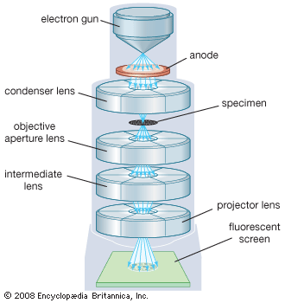

Lesson no. 11

Sample preparation in TEM
The process of specimen preparation in TEM involves many steps:
Fixation: Fixation of the specimen stabilizes the cell so that further change or damage to the cell will not happen. Through this process, the sample is preserved to give a snapshot in timeof the living cell. Fixation can be done through two methods as follows:
- Chemical fixation: This method is used for stabilizing biological samples. Chemical substances are used tocross link protein molecules with nearby molecules. The most frequently used chemical in this method is glutaraldehyde.
- Cryofixation: This method involves rapid freezing of the sample in either liquid nitrogen or liquid helium . The water content in the sample thus gets transformed into a vitreous ice form.
- Rinsing: The tissue fixation process may cause increased acidity in the specimen. To prevent this condition and maintain the pH, it should be rinsed properly using a buffer such as sodium cacodylate.
- Secondary fixation: To increase the contrast of the minute structures inside the specimen and give more stability, a secondary fixation is carried out using osmium tetroxide (OsO₄). Without inducing any change in the features of the structure, OsO₄ transforms the proteins into gels and increases the contrast between nearby cytoplasm by binding regions of phospholipid heads.
Dehydration: Freeze drying, or dehydration, of the specimen is the process by which the water content in the specimen is replaced with an organic solvent. Ethanol and acetone are the frequently used solvents in this method. Dehydration is important as the epoxy resin used in further steps does not mix with water.
Infiltration: In infiltration, epoxy resin is used to penetrate the cell, which will then occupy the space and make the sample hard enough to bear the pressure of sectioning or cutting. This process is also called embedding. The resin is then kept in an oven at 60° overnight to allow for setting. This process is called polymerization.
Polishing: After embedding, some materials are subjected to polishing. Polishing a specimen reduces scratches as well as other problems that can minimize the quality of the image. Ultrafine abrasives are used to give the specimen a mirror-like finish.
Cutting: For study under an electron microscope, the sample should be semi-transparent to allow the passage of electron beams through it. To achieve this semi-transparent nature, the sample is sectioned into fine sections using a glass or diamond knife attached to a device known as ultramicrotome. The device has a trough that is filled with distilled water. The sections cut are collected in this trough and are then moved to a copper grid to be viewed under the microscope. The size of each section should be between 30 nm and 60 nm to get the best resolution.
Staining: Staining in biological specimens is usually done twice – before dehydration and after sectioning. In this process, heavy metals like uranium, lead, or tungsten are used to increase the contrast between different structures in the specimen, and also to scatter the electron beams.
A cryofixed specimen may not undergo all these procedures. It can be directly subjected to cutting and then shadowed using vapors of platinum, gold, or carbon before visualization under the TEM.

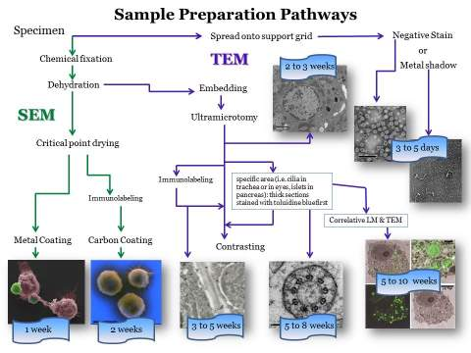

Lesson no.12
Scanning Electron Microscope (SEM)
It is a type of electron microscope that scans surfaces of microorganisms that uses a beam of electrons moving at low energy to focus and scan specimens.
The first Scanning Electron Microscope was initially made by Mafred von Ardenne in 1937 with an aim to surpass the transmission electron Microscope. He used high-resolution power to scan a small raster using a beam of electrons that were focused on the raster. He also aimed at reducing the problems of chromatic aberrations images produced by the Transmission electron Microscopes.

The Principle of the Scanning Electron Microscope
Unlike the Transmission Electron Microscope which uses transmitted electrons, the scanning electron Microscope used emitted electrons.
The Scanning electron microscope works on the principle of applying kinetic energy to produce signals on the interaction of the electrons. These electrons are secondary electrons, backscattered electrons and diffracted backscattered electrons which are used to view crystallized elements and photons. Secondary and backscattered electrons are used to produce an image. The secondary electrons are emitted from the specimen play the primary role of detecting the morphology and topography of the specimen while the backscattered electrons show contrast in the composition of the elements of the specimen.

Parts of a Scanning Electron Microscope (SEM)
The major components of the Scanning Electron Microscope include;
- Electron Source – This is where electrons are produced under thermal heat at a voltage of 1-40kV. the electrons the condense into a beam that is used for the creation of ana image and analysis. There are three types of electron sources that can be used i. e Tungsten filament, Lanthanum hexaboride, and Field emission gun (FEG)
- Lenses – it has several condenser lenses that focus the beam of electrons from the source through the column forming a narrow beam of electrons that form a spot called a spot size.
- Scanning Coil – they are used to deflect the beam over the specimen surface.
- Detector – Its made up of several detectors that are able to differentiate the secondary electrons, backscattered electrons, and diffracted backscattered electrons. The functioning of the detectors highly depends on the voltage speed, the density of the specimen.
- The display device (data output devices)
- Power supply
- Vacuum system
Like the transmission electron Microscope, the Scanning electron microscope should be free from vibrations and any electromagnetic elements.
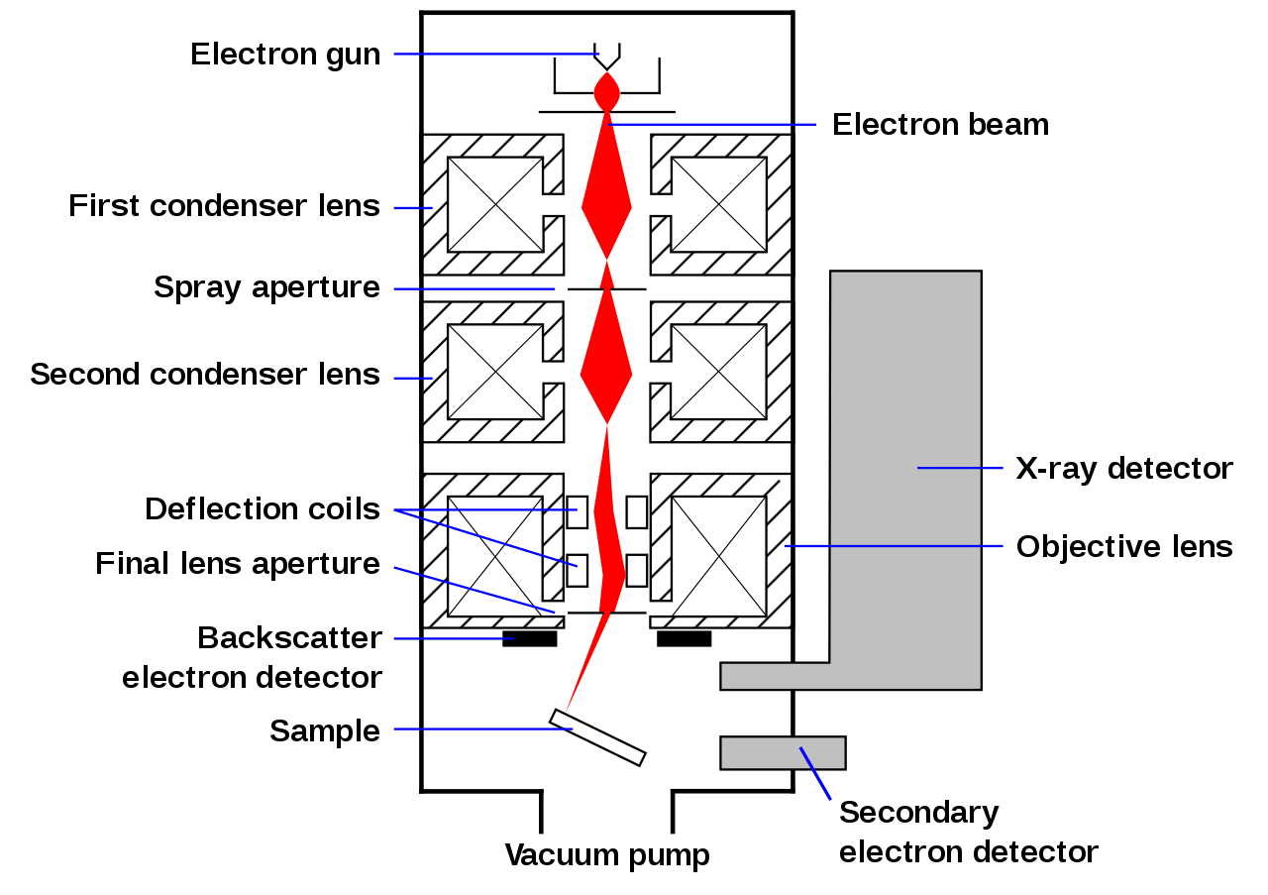

Advantages of the Scanning Electron Microscope (SEM)
- They are easy to operate and has user-friendly interfaces.
- They are used in a variety of industrial applications to analyze surfaces of solid objects.
- Some modern SEMs are able to generate digital data that can be portable.
- It is easy to acquire data from the SEM, within a short period of time of about 5 minutes.

Limitations
- They are very expensive to purchase
- They are bulky to carry
- They must be used in rooms that are free of vibrations and free of electromagnetic elements
- They must be maintained with a consistent voltage
- They should be maintained with access to cooling systems

Lesson no. 13
Fluorescence Microscope

Fluorescence microscope
- A fluorescence microscope is an optical microscope that uses fluorescence and phosphorescence instead of, or in addition to, reflection and absorption to study properties of organic or inorganic substances.
- Fluorescence is the emission of light by a substance that has absorbed light or other electromagnetic radiation while phosphorescence is a specific type of photoluminescence related to fluorescence.
- Unlike fluorescence, a phosphorescent material does not immediately re-emit the radiation it absorbs.
- The fluorescence microscope was devised in the early part of the twentieth century by August Köhler, Carl Reichert, and Heinrich Lehmann, among others.
- Working
- Light of the excitation wavelength is focused on the specimen through the objective lens. The fluorescence emitted by the specimen is focused on the detector by the objective. Since most of the excitation light is transmitted through the specimen, only reflected excitatory light reaches the objective together with the emitted light.
- Forms
- The “fluorescence microscope” refers to any microscope that uses fluorescence to generate an image, whether it is a more simple set up like an epifluorescence microscope, or a more complicated design such as a confocal microscope, which uses optical sectioning to get better resolution of the fluorescent image.
- Most fluorescence microscopes in use are epifluorescence microscopes, where excitation of the fluorophore and detection of the fluorescence are done through the same light path (i.e. through the objective).

Parts of Fluorescence Microscope
Typical components of a fluorescence microscope are:
- Fluorescent dyes (Fluorophore)
  - A fluorophore is a fluorescent chemical compound that can re-emit light upon light excitation.
  - Fluorophores typically contain several combined aromatic groups, or plane or cyclic molecules with several π bonds.
  - Many fluorescent stains have been designed for a range of biological molecules.
  - Some of these are small molecules that are intrinsically fluorescent and bind a biological molecule of interest. Major examples of these are nucleic acid stains like DAPI and Hoechst, phalloidin which is used to stain actin fibers in mammalian cells.
- A light source
  - Four main types of light sources are used, including xenon arc lamps or mercury-vapor lamps with an excitation filter, lasers, and high- power LEDs.
  - Lasers are mostly used for complex fluorescence microscopy techniques, while xenon lamps, and mercury lamps, and LEDs with a dichroic excitation filter are commonly used for wide-field epifluorescence microscopes.
- The excitation filter
  - The exciter is typically a bandpass filter that passes only the wavelengths absorbed by the fluorophore, thus minimizing the excitation of other sources of fluorescence and blocking excitation light in the fluorescence emission band.
- The dichroic mirror
  - A dichroic filter or thin-film filter is a very accurate color filter used to selectively pass light of a small range of colors while reflecting other colors.
- The emission filter.
  - The emitter is typically a bandpass filter that passes only the wavelengths emitted by the fluorophore and blocks all undesired light outside this band – especially the excitation light.
  - By blocking unwanted excitation energy (including UV and IR) or sample and system autofluorescence, optical filters ensure the darkest background.

Lesson no.14

Applications of Fluorescence Microscope
- To identify structures in fixed and live biological samples.
- Fluorescence microscopy is a common tool for today’s life science research because it allows the use of multicolor staining, labeling of structures within cells, and the measurement of the physiological state of a cell.

Limitations of Fluorescence Microscope
- Fluorophores lose their ability to fluoresce as they are illuminated in a process called photobleaching. Photobleaching occurs as the fluorescent molecules accumulate chemical damage from the electrons excited during fluorescence.
- Cells are susceptible to phototoxicity, particularly with short-wavelength light. Furthermore, fluorescent molecules have a tendency to generate reactive chemical species when under illumination which enhances the phototoxic effect.
- Unlike transmitted and reflected light microscopy techniques fluorescence microscopy only allows observation of the specific structures which have been labeled for fluorescence.

Lesson no.15
Confocal Microscopy

- Normally a conventional (wide-field) Microscope uses different wavelengths from a light source, to visualize and illuminate a large area of a specimen, forming fuzzy, murky and crowded images, because cell sample images are captured from all directions, without a focal point.
- To avoid these issues, a Confocal Microscope is used. In wide-field or Fluorescent microscopes, the whole specimen receives light, receiving complete excitement and emitting light which is detected by a photodetector on the microscope. However, with the confocal microscope, point illumination is the principle working mechanism.
- A specimen is stained with fluorochrome is examined. When a beam of light is focused at a particular point of the fluoro-chromatic specimen, it produces an illumination that is focused by the objective lens to a plane above the objectives. The objective has an aperture on the focal plane located above it, which primarily functions to block any stray light from reaching the specimen.
- A measure of the illumination point is about 0.25 to 0.8 um in diameter, determined by the objective numerical aperture and 0.5 to 1.5 um deep, with the brightest intensity.
- The specimen normally lies between the camera lens and the perfect point of focus, known as the plane of focus. Using the laser from the microscope, the laser scans over a plane on the specimen (beam scanning0 or by moving the stage (stage scanning). A detector then will measure the illumination producing an image of the optical section. scanning several optical sections, they are collected in a computerized system as data, forming a 3D image. The image can be measured and quantified.
- Its outcome is also favored by the aperture found above the objective which blocks stray light.
- Images produced by the confocal microscope has a very good contract and resolution capacity despite the thickness of the specimen. Images are stored in the high-resolution 3D image of the cell complexes including its structures.
- The main characteristic of the Confocal Microscope is that it only detects what is focused and anything outside the focus point, appears black.
The image of the specimen is formed when the microscope scanner, scans the focused beam across a selected area with the control of two high-speed oscillating mirrors. Their movement is facilitated by galvanometer motors. One mirror moves the beam from left to right on the lateral X-axis while the second mirror translates the beam along the Y-axis. After a scan on the X-axis, the beam moves rapidly back to the starting point to start a new scan, a process known as flyback. No information is collected during the flyback process, therefore the point of focus, which is the area of interest is what is illuminated by the laser scanner.

Parts of the Confocal Microscope
The Confocal Laser Scanning Microscope is made up a few components:
- Objective lens
- Out-of-focus plane
- In-focus plane
- Beam splitters
- Detector
- Confocal pinhole (aperture)
- Laser
- Oscillator Mirrors

Types of Confocal Microscope
- Confocal laser scanning Microscope – It uses several mirrors that scan along the X and Y axes on the specimen, by scanning and descanning, and the image passes through a pinhole into the detector.
- Spinning disk, also known as the Nipkow disk, is a type of confocal microscope that uses several movable apertures (pinholes) on a disc to scan for spots of light in a parallel manner over a specified plane, over a long period. The longer the time the less the excitation energy required for illumination, as compared to the Confocal laser scanning microscope. Lessened excitation energy reduces phototoxicity and photobleaching, hence its mainly used to imaging live cells.
- Dual spinning Disk or Microlens enhanced confocal Microscope -, it was invented by Yokogawa electric; it works similarly to the spinning disk, the only difference is, it has a second spinning-disk with micro-lenses that is found before the spinning disk that contains the pinholes. The micro-lenses capture broadband of light focusing it into each pinhole, thus increasing the amount of light that is directed into each pinhole, reducing the amount of light that is blocked by the spinning disk. This Confocal Microscopes with enhanced Microlenses are much more sensitive than the spinning disks.
- Programmable array Microscope (PAM) – this type of confocal microscope uses a spatial light modulator (SLM – an object that imposes some form of spatially-varying modulation on a beam of light). The SLM has a set of movable apertures (pinholes), with arrays of pixels of opacity, reflectivity or optical rotation. The SLM also has microelectrochemical mirrors that capture the image by a charge-coupled device (CCD) camera.
Each of the confocal microscopes has its advantages and disadvantages, but they all capture the images by recording the images and sometimes they can be programmed to get high-density images, especially the Programmed array Microscope and the Spinning disk confocal Microscope.

Applications of the Confocal Microscope
The Confocal Microscope is used in a wide range of fields including Biomedical sciences, Cells Biology, genetics, Microbiology, Developmental Biology, Spectroscopy, Nanoscience (nanoimaging) and Quantum Optics.
- In Biomedical sciences, it is used in the analysis of eye corneal infections, by quantifying and qualitatively analyzing the endothelial cells of the cornea.
- Used to identify the presence of fungal elements in the corneal stroma, during keratomycosis infection, or rapid diagnosis and quick therapeutic response.
- It is used in pharmaceutical industries, to ensure the maintenance of thin-film pharmaceuticals, allowing control of the quality and uniformity of drug distribution.
- It is used to retrieve data from some 3D optical storage systems. This has helped in quantifying the age of Magdalen papyrus.

Limitations
- They have a limited number of excitation wavelengths, with very narrow bands.
- They are expensive to produce the ultraviolet rays used by the Confocal Microscopes
- They are also expensive to manufacture and to purchase.

